Project Planning Phase

Date | 6 July 2026
Team ID | SWTID-20264431
Project Name | Strategic Product Placement Analysis

Product Backlog, Sprint Schedule, and Estimation

Sprint | Functional Requirement (Epic) | User Story Number | User Story / Task | Story Points | Priority | Team Members
Sprint-1 | Data Rendering | USN-1 | Import Retail Sales Dataset into Tableau Public. | 2 | High | 5
Sprint-1 | Data Preprocessing | USN-2 | Validate fields, data types and clean dataset. | 3 | High | 5
Sprint-2 | Interactive Filters | USN-3 | Apply Product Position, Product Category and Consumer filters. | 2 | High | 5
Sprint-2 | Calculated Fields | USN-4 | Create Price, Competitor Price and Sales Volume calculations. | 2 | High | 5
Sprint-2 | Sales Analysis | USN-5 | Create Horizontal Bar Chart for Average Sales Volume. | 2 | High | 5
Sprint-2 | Promotion Analysis | USN-6 | Create Text Table for Promotion vs Price vs Sales. | 2 | Medium | 5
Sprint-2 | Customer Analysis | USN-7 | Create Donut Chart for Consumer Demographics. | 2 | Medium | 5
Sprint-2 | Product Placement Analysis | USN-8 | Create Tree Map for Product Category & Position. | 3 | High | 5
Sprint-2 | Traffic & Pricing Analysis | USN-9 | Create Packed Bubble & Clustered Bar Charts. | 2 | Medium | 5
Sprint-2 | Seasonal Performance | USN-10 | Create Stacked Bar & Pie Charts. | 2 | Medium | 5
Sprint-2 | Dashboard Design | USN-11 | Develop interactive Tableau Dashboard. | 5 | High | 5
Sprint-2 | Story Design | USN-12 | Create Tableau Story with 3 Story Points. | 3 | High | 5

Project Tracker, Velocity & Burndown Chart: (4 Marks)
Sprint | Total Story Points | Duration | Sprint Start Date | Sprint End Date (Planned) | Story Points Completed (as on Planned End Date) | Sprint Release Date (Actual)
Sprint -1 | 05 | 4 Days | 27 June 2026 | 30 June 2026 | 05 | 30 June 2026
Sprint -2 | 25 | 7 Days | 01 July 2026 | 07 July 2026 | 25 | 07 July 2026

Velocity:
Imagine we have a 11-day sprint duration, and the velocity of the team is 11(points per sprint). Let’s calculate the team’s average velocity (AV) per iteration unit (story points per day)

Average Velocity (AV) = Velocity / Sprint Duration

AV = 25/11

AV = 2.73 Story Point per Day
Burndown Chart:
A burn down chart is a graphical representation of work left to do versus time. It is often used in agile software development methodologies such as Scrum. However, burn down charts can be applied to any project containing measurable progress over time.

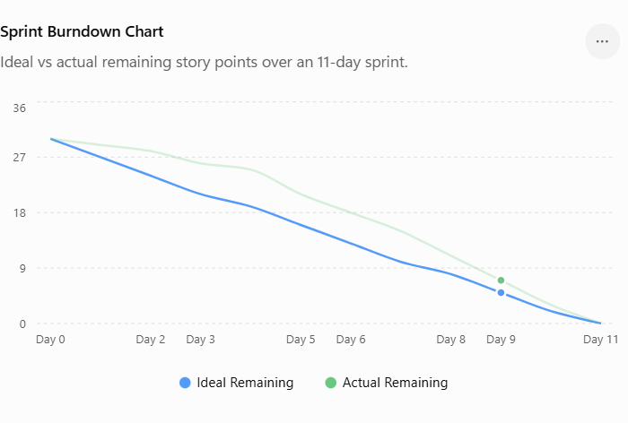

The Burndown Chart illustrates the remaining story points throughout the project timeline. The Ideal Remaining line represents the planned completion rate, while the Actual Remaining line reflects the team's real progress. Initially, the team progressed slightly slower than planned; however, by the end of the project, all 30 Story Points were completed successfully. This indicates effective sprint planning, timely task completion, and successful project delivery.

